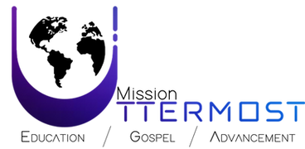

We are very excited to host our first Mission Uttermost Prayer Camp on June 29 - July 1. We look forward to getting to know each of you and seeing how the Lord will work in our hearts as we prepare for future missions trips.
Please be sure you have filled out the registration form online and review the following preparation list:
WHAT TO PACK
- Ladies 30-50 liter backpack/Men 50-60 liter backpack (Be sure you break in your pack, to be sure it’s comfortable and sturdy for the long hikes we will be taking. Keep in mind your pack will be with you most of the time.)
- Sturdy pocket knife
- Fire starting flint
- Wet wipes (plan for 20 max per day)
- Hand Sanitizer
- Grayl Purifier Water Bottle / LifeStraw / Sawyer
- Sandwich bags
- Bug spray
- Older Bible
- Notebook/pen
Clothing:
- Comfortable and appropriate for outdoor activities.
- Skirts longer than the knee
- A good pair of hiking shoes.
- Good breathable, comfortable pair of socks. (good idea to carry an extra pair in your pack)
* Be prepared to hike 5-10 miles per day

Basic medical kit including:
- Tourniquet (one per group)
- Blood clot
- Basic band aides
- Multi tool
- Aspirin/Ibuprofen
- Antibacterial ointment
(For more details. Go to My medic web site. Where you can find more ideas for your med kit.)

Food:
- MRE’s (if you can find them)
- Canned/packs of tuna and chicken
- Ramen noodles
- Granola bars
- Beef jerky
- Nut or trail mix for protein
- (Anything easy and nonperishable)
*Rice and beans will be provided at least once a day
**Remember all food will need to be carried in your pack and may be your only sustenance on some days.

Drinks:
- Water flavoring
- Powder coffee/creamer

Bedding:
- Hammock/bed roll
- Mosquito net
- Travel pillow/inflatable pillow

Travel tip:

Be sure to be well hydrated before and continue to hydrate during the trip. LOTS OF WATER
Be sure to have protein items and make sure to eat these on purpose.

